Control Engineering

Handout – Online Laboratory 5

Name: *Colda Andreea Ariana*

Group: *30332*

For the process described by



and the performance indicators

a)  respectively b) 

following the above described steps, design a P and a PI controller. Simulate the step and ramp output of the closed loop to highlight the performance indicators.

a) 

*1.852*

*Hd = ----------- open loop tf HP(s) = Vr = 0.5291*

*0.5 s^2 + s*

*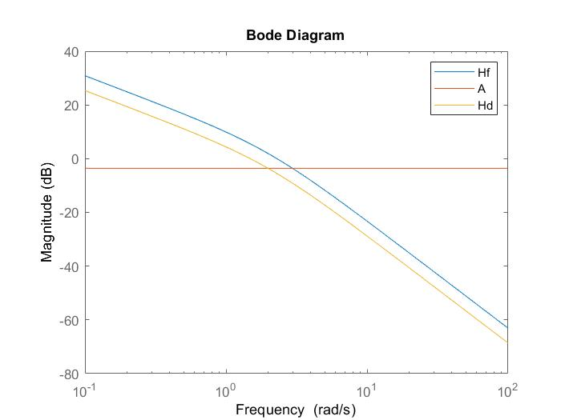*

*Add graphical proofs of performance, step and ramp responses.*

*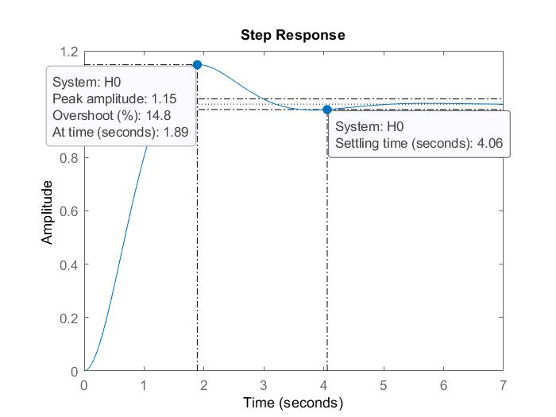*

*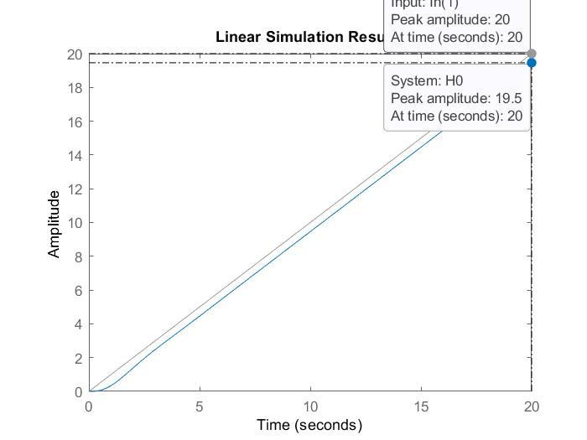*

b) 

*Add the obtained P controller here Vr = 0.3387*

*Add the obtained PI controller here 83.35 s + 8.752*

*HPI = ------------------------*

*22.5 s^3 + 45.51 s^2 + s*

*Add Bode diagrams for both Hf and the open loop system with the PI controller (on the same plot).*

*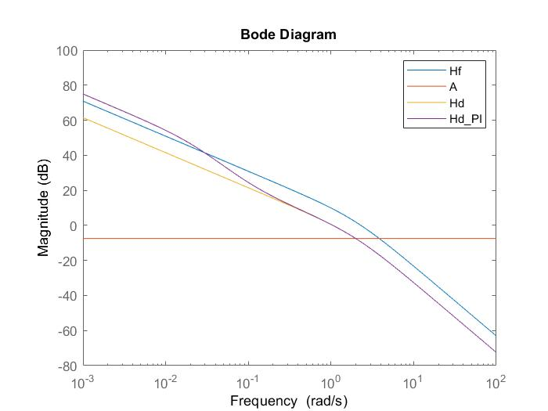*

*Add graphical proofs of performance, step and ramp responses.*

